BLINKIT ANALYSIS

KPI’s

1. Total sales

select cast(sum(Total_sales)/1000000 as decimal(10,2)) as total_sales_millions from blinkit_data;

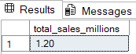

2)Average sales

select cast(avg(Total_sales) as decimal(10,2)) as Average_Sales from blinkit_data;

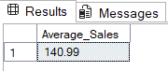

3)No of items

select count (* ) as No_of_Items from blinkit_data;

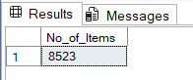

4)average rating

select cast(avg(Rating) as decimal(10,2)) as average_rating from blinkit_data;

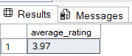

GRANULAR REQUIREMENTS

1)total sales by fat content

select Item_Fat_Content,

cast(sum(Total_Sales) as decimal(10,2))as total_sales,

cast(avg(Total_sales) as decimal(10,2)) as Average_Sales,

count (* ) as No_of_Items,

cast(avg(Rating) as decimal(10,2)) as average_rating

from blinkit_data group by Item_Fat_Content;

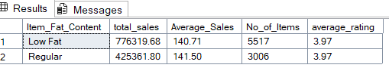

2)Total sales by item type

select Item_Type,cast(sum(Total_Sales) as decimal(10,2)) as Total_Sales from blinkit_data group by Item_Type;

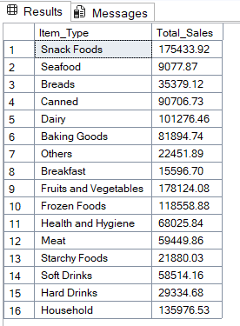

3)Fat content by outlet for total sales

select Item_Fat_Content,Outlet_Location_Type, cast(sum(Total_Sales) as decimal(10,2)) from blinkit_data group by Item_Fat_Content,Outlet_Location_Type;

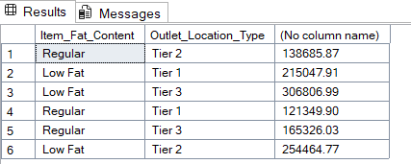

4)Total sales by outlet establishment

select Outlet_Establishment_Year,cast(sum(Total_Sales) as decimal(10,2)) as Total_Sales from blinkit_data group by Outlet_Establishment_Year;

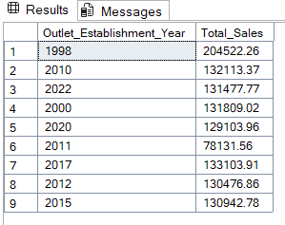

5)Percentage of sales by outlet size

select Outlet_Size,cast(sum(Total_Sales)as decimal(10,2)) as Total_Sales,

cast((sum(Total_Sales)*100/sum(sum(Total_Sales)) over()) as decimal(10,2)) as sales_percentage from blinkit_data

group by Outlet_Size;

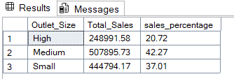

6) sales by outlet location

select Outlet_Location_Type,cast(sum(Total_Sales) as decimal(10,2)) as Total_Sales from blinkit_data group by Outlet_Location_Type;

